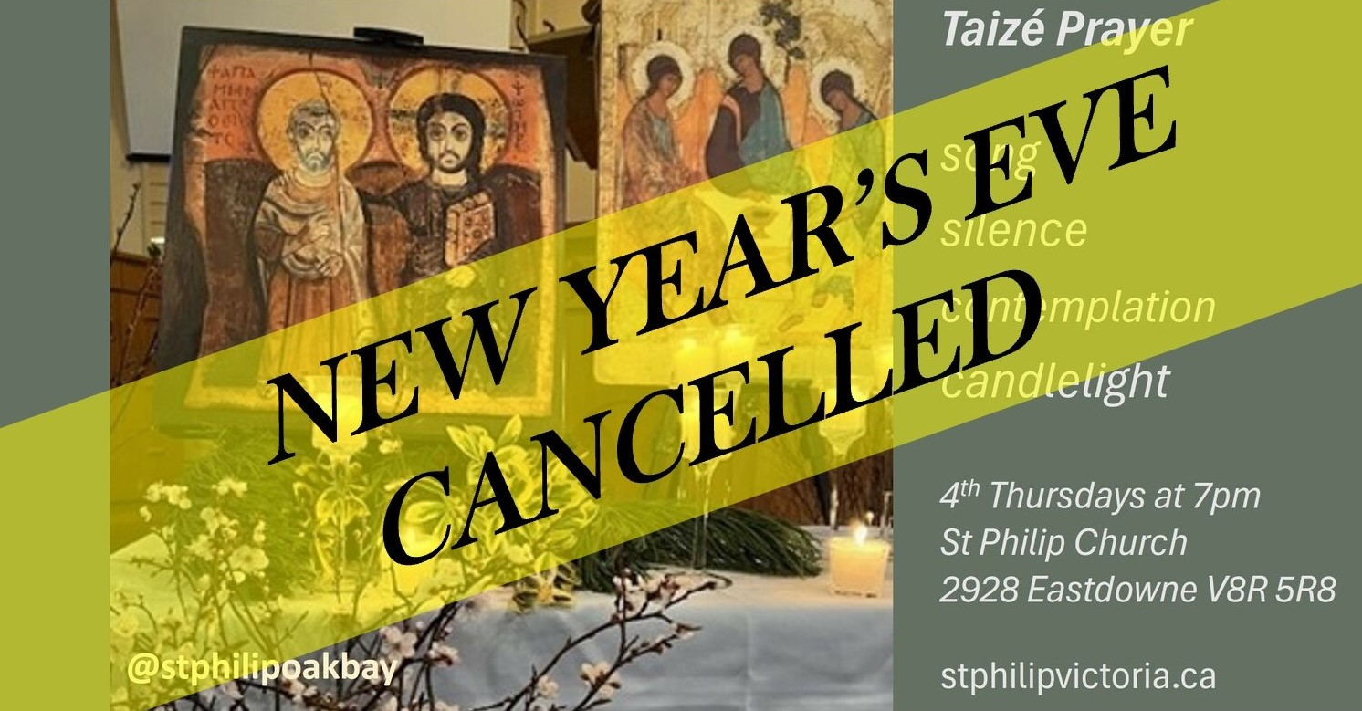

With apologies, the **New Year's Eve Prayer in the Style of Taizé at St Philip has been cancelled.**

Please join us at St Philip Oak Bay in 2025 for a candlelit service of song, silence and contemplation, in the style of the Taizé Community, on the last Thursdays of the month at 7pm:

**30 January 2025  
27 February  
27 March**